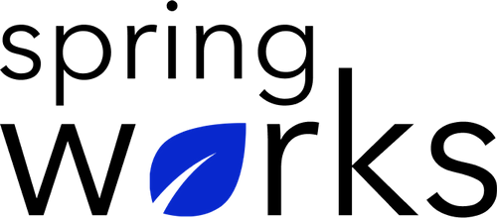
Free Template – Employee Empowerment Survey

Understand how to support and engage with your employees better

This employee empowerment survey template is designed to gather feedback from the employees regarding the support provided to them to do their job at the workplace. Copy this template to your Google Drive and customize it for your organization.

Communication (to be added as review instructions):

Your responses to this survey are anonymous. The leaders are committed to analyzing your results and taking action. Please answer this quick survey by <HOUR OF THE DAY> on <DATE>.

Thank you for your time. Your responses will help our organization become a better place to work. If you have any questions about the survey, please contact [insert name of contact person].

Demographic Information:

The following information is requested so that meaningful analysis and comparisons of group results can be made. Please check the circle corresponding to your answer.

Q: Your Gender:

- Male
- Female

Q: Your Department:

- Marketing
- Operations
- Tech
- Accounting
- HR

Employee Empowerment Questionnaire

To answer clearly what you think or feel about each item, please follow these steps:

- Read each item fully before you start to mark your answer.
- Pick the one answer which most nearly says what you think or how you feel.
- While completing the questions, be sure to read the special instructions which are included.

Choose the most appropriate answer:

Q: Do you feel you have the ability to make important decisions?

- Yes, all the time
- Yes, sometimes
- Neutral/I don't know
- Never

Q: To what extent do you feel able to make suggestions for new ideas or approaches?

0 | 1 | 2 | 3 | 4 | 5 | 6 | 7 | 8 | 9 | 10

Q: Which of the following do you agree most with?

- I feel like a valued member of the company and I understand I am making an impact
- I know what my role is and where it fits in the company
- I don't understand how my role impacts on the wider business

Q: Do you feel empowered at work?

- Yes
- No

Q: My department uses employee feedback to make improvements:

- Strongly agree
- Agree
- Neutral
- Disagree
- Strongly disagree

Q: This is the type of job in which I can feel a sense of accomplishment:

- Strongly agree
- Agree
- Neutral
- Disagree
- Strongly disagree

Q: I receive encouragement to come up with new and better ways of doing things:

- Strongly agree
- Agree
- Neutral
- Disagree
- Strongly disagree

Q: I feel valued as a team member:

- Strongly agree
- Agree
- Neutral
- Disagree
- Strongly disagree

Q: What are the three things you like about the organization?

Q: What could we have done differently?

Thanks for your response!

